**SetOperations User Manual**

A collection of Java based functions for set operations

Cachary Tolentino

CSCI-3327

**Table of Contents**

**Software Description3**

Detailed Description3.1

System Requirements3.2

**Installation Guide4**

**Class Overview6**

Union Function6

Intersect Function7

Complement Function8

**Software Description**

A collection of Java based functions for set operations

**Detailed Description**

The SetOperations class contains three total functions: Union, Intersect, and Complement. Each function can perform its set operation equivalent. Each function requires two inputs of ArrayList containing Strings.

**System Requirements**

* A working device, primarily a desktop or laptop
* An IDE (ex: VSCode, Eclipse, etc…)
* Java JDK (Ver. 17 & up) & JRE (SE 17 & up)

**Installation Guide**

To start, download the two files: “SetOperations.java” and “TestSetOperations.java” (optional).

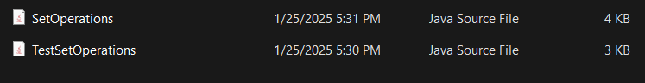

After downloading the files, move each file to your project folder. For this guide VSCode will be used as the preferred IDE. After moving your files, you can open your IDE of preference. In your IDE you can either open the file directly or the folder in which you put the files in.

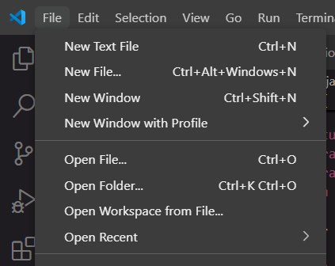

Once you’ve opened the folder or the file, it should appear on your file/folder list.

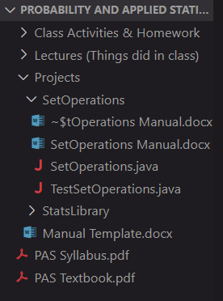

From here on you can start using the class as is. But, if you want to quickly check the various functions provided by the class, using the TestSetOperations file, you can run it and see some results from the console.

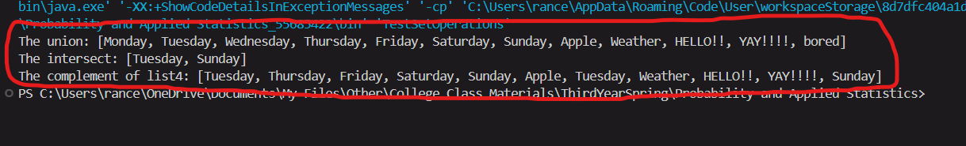

**Class Overview**

**Union Function**

The Union Function requires two **ArrayList<String> parameters** and it returns an **ArrayList<String>** value. Each parameter could be a subset of a set. The return value contains the union values of the given pair of parameters. This function only works for String type ArrayLists.

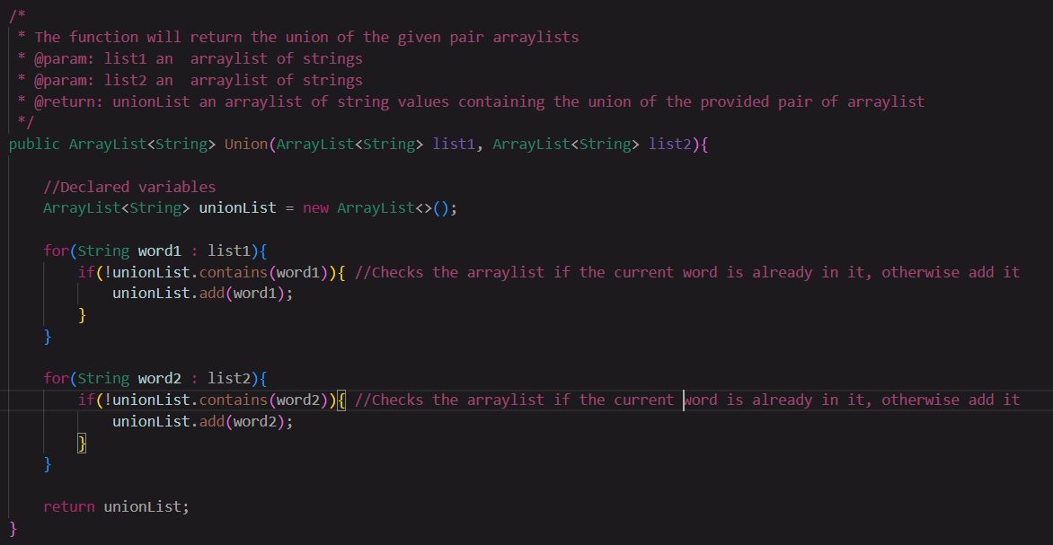

**Intersection Function**

The Intersect Function requires two **ArrayList<String> parameters** and it returns an **ArrayList<String>** value. Each parameter could be a subset of a set.The return value contains the union values of the given pair of parameters. This function only works for String type ArrayLists.

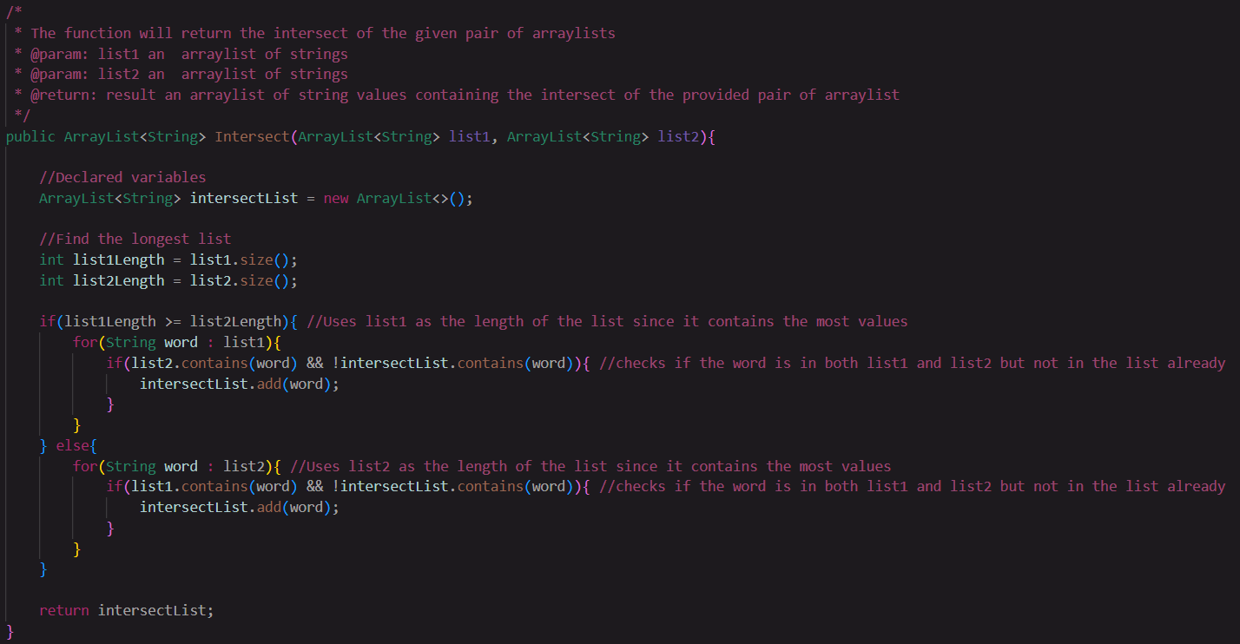

**Complement Function**

The Complement Function requires two **ArrayList<String> parameters** and it returns an **ArrayList<String>** value. The first parameter must be the set of all possible values. The return value contains the union values of the given pair of parameters. This function only works for String type ArrayLists.

